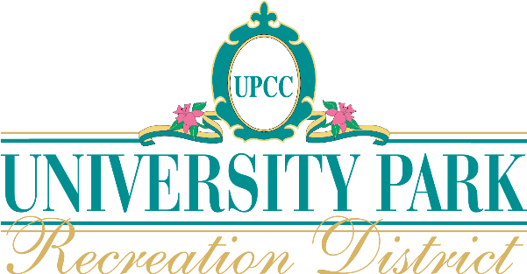

To University Park Lot Owners and Residents –
The candidate nomination process will close at 5 PM next Monday, October 24. Two seats for four-year terms are open for election to the Board of Supervisors for the University Park Recreation District, a.k.a. the Country Club. Thus far three candidates have submitted nominations: Jory Berkwits, Bill DiPaolo, Rusty Piersons. Candidate profiles will be published on the RD website following the closing of nominations.
In the three years since Turnover much has changed in our community. As Lot Owners we have the responsibility for ensuring that governance matters meet our expectations. Electing people to serve on community boards like the RD Board of Supervisors is important and we should encourage our neighbors to serve. In five days, nominations close so if you or someone you know should be on the candidates’ list please take immediate action.
If you have an interest in self-nomination or nominating someone else, please review the Call for Candidates on page 2.
KEY DATES FOR THE 2022 RD ELECTION
October 12 – November 3 - Voter registration process for Lot Owners and Residents, with a goal to maximize eligible voter participation.
October 24 by 5PM – Final date for Candidate nominations.
Late October and early November dates to be determined – Candidates’ Forums (three live and one virtual are planned).
November 4 – Ballots and Proxies distributed (voting begins).
December 6 – Final election date with poll closing at 12:00 noon. Immediately following ballot verification by the Election Chair the results will be announced.
QUESTIONS AND ANSWERS
For more information contact John Bondur, Election Chair at his email address (jkbondur@comcast.net). Volunteers working with the Election Chair and District Manager on the election process include Jim Corrigan, Todd Emmerson, Marc Loundy, Dale Otterman, Marcia Selep, Pat Singletary.
Page 1 of 3
CALL FOR CANDIDATES – 2022 BOARD OF SUPERVISOR ELECTION
University Park Lot Owners and Residents are encouraged to run for election to two Supervisor positions on the UPRD Board. The election is pursuant to the Manatee County Board of Supervisors Ordinance 18-29 (the “Charter”), Florida’s Sunshine Laws and other State and County statutes.
REQUIREMENTS FOR CANDIDATES
Candidate information as described on the Candidate Nomination form presented herein on page 3 must be received by the District Manager by 5 PM on October 24, 2022. The information will be posted at https://universityparkrd.com as it is received through the election date.
Candidates’ Forums conducted in person, virtually, or both will soon be scheduled at various times between in late October and early November 7 to ensure voters have an opportunity to meet and interact with the candidates. Candidate participation is encouraged but not required.
Successful candidates (those elected) must annually complete a financial disclosure statement, Florida Form 1, and other ethics requirements available for review at https://ethics.state.fl.us/Research/EthicsLaws.aspx.
TERMS FOR BOARD POSITIONS
The 2022 election will determine the persons to fill two Supervisor positions each for four-year terms. The two candidates receiving the most votes will be elected.
BOARD SUPERVISOR RESPONSIBILITIES
The Board of Supervisors meets regularly to determine and oversee policies and strategies to operate, maintain and enhance the Country Club and its properties.
Supervisors should:
- Be familiar with Florida Sunshine Laws outlining how and when they may communicate with each other on RD business.
- Make the effort to learn and commit to the Mission, Vision and Core Values of the Club, and the financial structure of a successful Club and the Recreation District.
- Understand the RD Charter and the policies under which the Board operates.
- Take a holistic approach to represent all UP Lot Owners and Residents and provide unbiased input on matters brought before the Board after listening to differing points of view.
- District Counsel will provide a brief overview of the roles for the new Board Supervisors upon election.
Page 2 of 3

CANDIDATE NOMINATION FORMAT
Please include a head and shoulder photo (either B&W or color; medium resolution). The photo and candidate information listed below will be posted on the RD website.
(Candidate Name) is hereby nominated as a candidate for the 2022 University Park Recreation District Board of Supervisors election.
University Park Address
Phone Numbers (indicate home/cell/or both)
Email Address
FOR THE FOLLOWING INFORMATION PLEASE LIMIT THE TEXT LENGTH TO NO MORE THAN 500 WORDS RESPONDING TO THESE ITEMS:
- Candidate’s personal description and pertinent background
- Qualities and pertinent experiences you will bring to service as an RD Supervisor, including historical active involvement in University Park Country Club, UPRD, and the UP community.
- An expression of your understanding of the requisite investment of time required to fulfill the Supervisor’s role and commitment to serve the full term.
- What priorities do you envision for the RD in the near term and over the next four years, and beyond?
- In assessing the current and future needs of the Recreation District what steps do you see as necessary?

PLEASE SUBMIT INFORMATION SO IT IS RECEIVED NO LATER THAN 5PM ON OCTOBER 24, 2022, TO:
University Park RD
c/o PFM Group Consulting LLC
3501 Quadrangle Blvd., Suite 270
Orlando, FL 32817
Email Address: carvalhov@pfm.com
Page 3 of 3

