MEMORANDUM

TO: Supervisors of the University Park Recreation District

FROM: Hank Fishkind, Ph.D., President

SUBJECT: Response to “Now is the Time” Email from Ms. Lordi

DATE: January 22, 2019

VIA: Email only and Posted to UPRD Website

- Once again it is necessary to respond to another fallacious and inflammatory email from Ms. Lordi. Her email is included in Attachment #1 for reference.

- Ms. Lordi claims that “there appears to be no promise of objective third party authentication of the vote tally this may well be a case of the fox guarding the hen house”. This is clearly not correct, and Ms. Lordi knows that her statements are false.

- First, the UPRD website clearly demonstrates that ballots will not be opened by my office. Below is a screen shot from the website showing the return ballot. The “DO NOT OPEN” is clearly shown reflecting the protocol to be followed by my office.

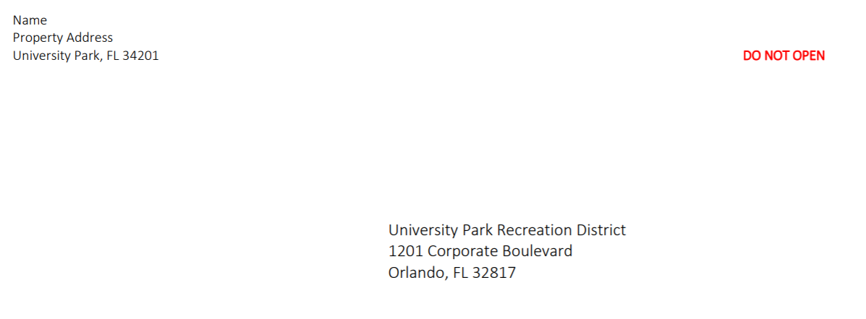
- Tellingly, Ms. Lordi’s email was sent at 12:16 PM today. This is more than 90 minutes after our workshop ended.

- At our meeting this morning Mr. Lordi asked why the ballots were being mailed to my office, and how we were handling the procedure for vote counting. I explained that the District has hired an accounting firm, DiBartolomeo, McBee, Hartley & Barnes to oversee the voting.

- I further explained that ballots are sent to my office to allow us to record their identification numbers on the return envelopes. The ballots will not be opened by my office. All ballots will be taken to the polling location, unopened, and given to the accountants for opening and tallying of the votes.

- This was confirmed by Chairman Wood in response to a follow up question. Mr. Wood explained that the ballots would only be opened by the accountants on 2-7-19.

- Yet, not 90-minutes later Ms. Lordi sent her email claiming the contrary. Clearly, Ms. Lordi’s claim that the voting procedure is tainted is untrue, and she knows or should have known this before making her false allegation.

- Ms. Lordi’s attempt to disrupt our voting process is clearly failing. My office has already received 191 ballots as of today.

- Since I have previously responded to the balance of Ms. Lordi’s recycled and discredited claims concerning the District and our processes, I shall not repeat them again here.

Attachment #1

From: Suzan Lordi <smltal@yahoo.com>
Date: January 22, 2019 at 12:16:12 PM EST
To: Suzan Lordi <smltal@yahoo.com>
Subject: The Time is NOW
The Time Is NOW

By now you have received the ballot for the Bond referendum. Because there appears to be no promise of objective third party authentication of the vote tally this may well be a case of the fox guarding the hen house. Therefore, we strongly recommend you return your ballot in person to the Varsity Club on February 7 accompanied by proper identification and proof of ownership. Joan Gushiken has offered to advise you on what you will need to bring with you to validate your vote. You can email her at: jfrances.gushiken@yahoo.com.

Every NO vote is needed to vote down the issuance of a $24M bond. Homeowners should strive to own the UPCC and not burden every home with a 30 year lien for a Municipal Park.

Before casting your vote on the Recreation District Bond referendum we urge you to learn as much as possible about the implications of approving this bond, and thus the RD. Consider the enormity of its cost, and how the uncertainty of its future cost will ultimately affect the value of your property. Your current elected board has the authority to assess any monies they choose including the most recent decision to proceed with a $24M bank line of credit in addition to the $24M bond further increasing the cost to every home owner. It is the board which will control all fees and additional assessments for the next 32 years.

If you agree that turning University Park into a Recreation District is NOT in your best interest, and in order to have an accurate tally of the NO votes, we ask that you vote NO (AGAINST BONDS) on the ballot provided and return it in person to the Varsity Club. Then email Hansa Shah at hansa1943@gmail.com
to say that you have voted NO so that we can also count the vote totals. Your name will not be publicized. If we can defeat this Bond, and thus the RD, we can then pursue a more collaborative approach to the acquisition of the facilities in a manner, and outcome that benefits all the residents of University Park.

Thank you

